State space search
“It is complete set of states including start and goal states, where the answer of
the problem is to be searched”.

Problem
“It is the question which is to be solved. For solving the problem it needs to be
precisely defined. The definition means, defining the start state, goal state,
other valid states and transitions”.

A state space representation allows for the formal definition of a problem which
makes the movement from initial state to the goal state quite easily. So we can
say that various problems like planning, learning, theorem proving etc. are all
essentially search problems only.

State space search is a process used in the field of computer science, including
artificial intelligence (AI), in which successive configurations or states of an
instance are considered, with the goal of finding a goal state with a desired
property.

For Example:
The eight tile puzzle problem formulation
The eight tile puzzle consist of a 3 by 3 (3*3) square frame board which holds 8
movable tiles numbered 1 to 8. One square is empty, allowing the adjacent tiles
to be shifted. The objective of the puzzle is to and a sequence of tile movements
that leads from a starting configuration to a goal configuration.
The states of 8 tile puzzle are the different permutations of the tiles within
frame.
Lets do a standard formulation of this problem now.
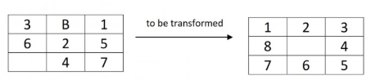
States: It species the location of each of the 8 tiles and the blank in one of the
nine squares.

Initial state : Any state can be designated as the initial state.

Goal : Many goal configurations are possible one such is shown in the figure

Legal moves ( or state) : They generate legal states that result from trying the
four actions-
Blank moves left
Blank moves right
Blank moves up
Blank moves down

Path cost: Each step costs 1, so the path cost is the number of steps in the
path.
The tree diagram showing the search space is shown in _figure.
